

Load DynamiX

1G Series Model 3000 and

10G Series Model 5000

Quick Start Guide

Support

Open support cases by sending email to: support@loaddynamix.com

Table of Contents

Hardware
- What ships with the Load DynamiX product – a list of the contents of the Load DynamiX product.
- Hardware Installation – how to install the Load DynamiX Appliance hardware.
- Admin Network, Date and Time Configuration – how to configure the IP address and Date /Time on the Load DynamiX 1G Series Model 3000 and 10G Series Model 5000 Appliances.
Software Setup
- GUI Software Installation – workstation software requirements, how to install the Load DynamiX TDE and configure the environment for optimum TDE-to-Appliance communications.
- Licensing – how to Activate and License a Load DynamiX Appliance.
- Initial System Configuration – configure and run a test Project to validate that the workstation, appliance and admin network are working correctly.

Troubleshooting, Automation and Other Topics
- Running Load DynamiX Projects – things to consider in preparation for running a Load DynamiX Project.
- Information Typically Required to Design a Load DynamiX Project – a detailed list of information that may be needed when implementing a Load DynamiX Project.
- Load DynamiX Automation – software requirements for using Load DynamiX Automation on a Linux system.
- Appliance Admin User Interface – screen shots of the admin interface for the Load DynamiX Appliance.
- Troubleshooting Tips – product installation and project execution failure troubleshooting information.

NOTE: Microsoft .NETv3.5.1 is required on the Management Workstation (see section D)

SwiftTest recently changed its name to Load DynamiX. Re-branding of our products by our product team is currently in-progress. Until release of the newly branded products, we are providing this documentation containing the SwiftTest name, consistent with the products currently generally available to our customers and prospects.

A) What ships with a Load DynamiX product

- Appliance (one of the below)
- 1G Series Model 3000 with eight 1000BASE-T Test Ports
- 10G Series Model 5000 with two 10GbE Test Ports
- Load DynamiX USB thumb drive (including a PDF version of this document)
- Hard copy of this document
- Rack mounting hardware (rails, etc)
- License file for the licensed Protocols for this Appliance

B) Hardware Installation

Dimensions: Height 3.5”, Width 17.2”, Depth 17.7”

Installation into a Rack
The Load DynamiX 1G Series Model 3000/10G Series Model 5000 shipping carton includes two sets of rail assemblies, two rail mounting brackets and the mounting screws required to install the system into a rack.

Temperature Considerations: Airflow on the Load DynamiX 1G Series Model 3000 and 10G Series Model 5000 Appliances is from front to back. The front of the Appliance has the Reset and Power buttons, and the Admin and Test ports. The Front of the Load DynamiX Appliance must be installed on the cool side of the rack in which it is located. Installing the Load DynamiX Appliance with the back of the Appliance on the cool side of the rack can result in chassis overheating and product failure.

Optional: The shipping carton also includes two extension rails that can be attached to the Load DynamiX 1G Series Model 3000/10G Series Model 5000 to allow it to be serviced without removing it entirely from the rack. These extension rails are not necessary for normal function of the device.

Providing Power
Plug the 2 power cords from the power supply units into a high-quality power source that provides protection from electrical noise and power surges. An uninterruptible power supply (UPS) is recommended. Using a different drop circuit for each power supply is also recommended. Both power supplies must be plugged in for proper function.

Network Cabling
The eight 1000BASE-T test ports on the Load DynamiX 1G Series Model 3000 Appliance support shielded or unshielded Category 5 twisted pair cables with RJ45 connectors. The 2 10GbE test ports on the Load DynamiX 10G Series Model 5000 are shipped with modular SFP+ transceivers that use an 850nm laser that supports Single-Mode or Multi-Mode Fiber cables with an LC connector. Other compatible SFP+ optical transceivers or SFP+ passive or active DA (Direct Attach) transceiver/cable (sometimes referred to as "Twinax" cables) combinations will also work with the Load DynamiX 5108S Appliance 10GbE ports. Mixing compatible cable types on the Load DynamiX 10G Series Model 5000 Test Ports is allowed (e.g. Port 0 may be connected to a switch that accepts the multi-mode fiber cable and LC connector while port 1 may be connected to a switch that supports only Twinax cables.

Communications Considerations
The Load DynamiX Appliance and TDE together create a test development and execution environment for performance, capacity and stress oriented networked storage tests. It is advisable to have high speed, low latency communications between the TDE and the Appliance to facilitate test development and results gathering. It is also advisable to have high speed, low latency communications between the Appliance and the device being tested to facilitate test execution.
If the network link between the TDE and Appliance is not high speed or has high latency, it is suggested that the TDE be installed on a Windows VM near the Appliance and the TDE be accessed via Remote Desktop or some other remote access solution. To optimize Appliance to device under test communications, it is recommended that as little network infrastructure as possible be between the Appliance's test ports and the device under test. Network infrastructure can add unexpected delay and complexity during test execution.

C) Admin Network, Time and Date Configuration

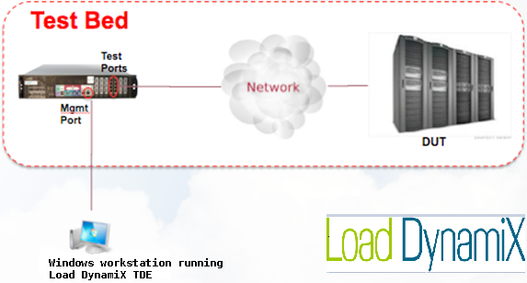
The Load DynamiX 1G Series Model 3000 and 10G Series Model 5000 Appliances have two types of ports - Admin and Test Ports (10000BASE-T ports on the 1G Series Model 3000 and 10GbE ports on the 10G Series Model 5000). The Test Ports are configured from the Load DynamiX TDE (the GUI). It is recommended that the Test Ports and Admin Ports be connected to different networks, as Test Ports can generate significant amounts of traffic, and can potentially overwhelm the network on which they are connected.

Ping- Load DynamiX Appliance Test Ports are only active during test execution so Pinging them prior to running a test will not produce a positive response. If it is necessary to Ping the Appliance Test Ports during test execution to verify that the Test Port is active, please limit the frequency and size of Ping requests as it can impact Test Port performance during test execution. Load DynamiX suggests setting the Ping packet size to less than 32 bytes (-s option on the linux/unix ping command or -l option on the Windows ping command)

Load DynamiX 1G Series Model 3000 Appliance (8x1000BASE-T Test Ports)

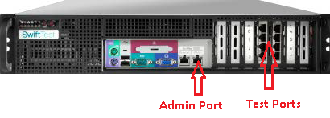

- Connect a 1000BASE-T Ethernet cable to the port labeled Admin on the front of the Appliance. Connect that cable to a network accessible by the computer on which the Load DynamiX TDE is to be installed (the Load DynamiX WorkStation). This is the ADMIN NETWORK.

- Connect a 1000BASE-T Ethernet cable between Test Ports 0 and 4 (top left and top right Test Ports, which are on the front right side of the Appliance). This back-to-back connection between Test Ports will be used to verify installation (see the Initial System Configuration section below). After the installation is complete and the initial Project is verified (see the Initial System Configuration section below), connect the test ports as desired for future test activity.

- If the Management IP address, subnet mask and default gateway have been pre-configured for you by Load DynamiX, go to Step 9.

- Connect a keyboard to the keyboard port and a monitor to the DB15 video port. Alternatively, connect a DB9 serial cable between the Appliance serial port and a terminal or PC. Settings for the serial port are 9600 Baud, 8 Data bits, 1 Stop bit, No Parity and No Flow Control.

- Log in to the admin interface on the Appliance (see section J) Appliance Admin User Interface below for the details of the Appliance Admin User Interface):
User Name: config
Password: config

- Change the network configuration of the Appliance to be on a network accessible by the Load DynamiX TDE. Select 1 Network settings and follow the configuration prompts to change the IP address, netmask, and default gateway address of the Appliance. This process sets the Appliance's Management IP address which will be used by the Load DynamiX TDE to interact with this Appliance. The Appliance admin interface and port do support DHCP. Unless specified by the customer, DHCP is the default for the IP address setting. However, unless the DHCP server is configured to give the Appliance a static IP address, it is not recommended that DHCP be used.

- Confirm the Date and Time configuration is set to US Pacific timezone. Select 2 Date/Time settings and follow the prompts to view the current the date and time settings to confirm that they are US Pacific timezone date and time. The date and time must be set to the current time and date of the US Pacific timezone. The Appliance admin interface does not support setting a time zone so the US Pacific time zone is assumed by the Appliance software. If the Appliance is installed in a facility other than in the US Pacific time zone, be sure that the time and date on the Appliance to the US Pacific timezone time (e.g. if the Appliance is installed in a facility in the US Eastern timezone, set the time to be three hours earlier than the current east coast time).

- Log out from the console and disconnect the cables.

- To check your setup, ping the Management IP address of the Load DynamiX Appliance from the Management WorkStation.

  - Open a browser on the WorkStation and type the Appliance Management IP Address into the address bar and hit return. The text “SwiftTest” should appear in the browser window..

  - If a. fails, Ping the Load DynamiX Appliance Management IP address (C:\Windows\System32\ping <IP Address>).

  - If the Ping is unsuccessful run the Trace Route command (C:\Windows\System32\tracert <IP Address>) to see where the routing process fails then go back to step 4 and verify the IP address, netmask and gateway address assigned to the Appliance. If these are correct, ensure that the Load DynamiX WorkStation is connected to a network that can access the network that the Admin Port is connected to.

Load DynamiX 10G Series Model 5000 Appliance (2x10GbE Test Ports)

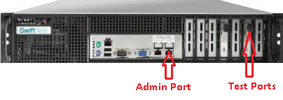

For a Load DynamiX 10G Series Model 5000 Appliance, follow the same procedure described above for the Load DynamiX 1G Series Model 3000 except that, in Step 2, the configuration of the ports for the test process described below should be changed to link Test Ports 0 and 1 with a 10GbE compatible cable.

The Load DynamiX 10G Series Model 5000 Appliance 10GbE physical test ports conform to the IEEE 802.3-2008 standard. The Load DynamiX 10G Series Model 5000 Appliance ships with two 10GbE SFP+ transceivers which use an 850nm laser and require a Multi-Mode Fiber cable with an LC connector.
10GbE Transceiver Support
Other compatible SFP+ optical transceivers or SFP+ passive or active DA (Direct Attach) transceiver/cable (sometimes referred to as "Twinax" cables) combinations will also work with the Load DynamiX 10G Series Model 5000 Appliance 10GbE ports.
To verify that an optical SFP+ transceiver other than that which is shipped with the Load DynamiX 10G Series Model 5000 or an SFP+ DA transceiver/cable combination is compatible with the Load DynamiX 10G Series Model 5000 Appliance, connect the two Load DynamiX 10G Series Model 5000 10GbE ports in a back to back configuration with the transceiver/cable combination and run one of the Load DynamiX back-to-back sample Projects such as CIFS-SMB Full Duplex Payload. If the Project runs successfully then the optical SFP+ transceiver or DA SFP+ transceiver/cable combination are compatible with the Load DynamiX 10G Series Model 5000 10GbE ports. Examine the Client Log file of the Project run to see the SFP+ transceiver feedback that is captured there in a message of the form:
Info <DATE> Device [x]: SFP+ Transceiver initialization successful.
Debug <DATE> Device [x] SFP+ Transceiver Vendor OUI [0x.....], capabilities [0x..] [0x..] [0x..]
For this cable/transceiver combination to work with a DUT or a 10GBe switch, the cable/transceiver must also be compatible with the target connection (DUT or switch). If the back-to-back test is successful but a test using a connection to a DUT or switch is not, it is possible that the cable/transceiver combination is not compatible with the target. You can verify link status using the TDE Ports & Appliances > Appliances tab entry for the Load DynamiX 10G Series Model 5000 but link status does not guarantee that traffic can be sent over this connection. When running a test to verify a working connection, include a Tracing Resource in the project. If the PCAP file that results from the Tracing Resource contains only ARP packets then the cable/transceiver combination is incompatible with the target even if the link status appears OK.
Messages of the form “<ERROR Device[x] Generic Failure: Status Code [y]>” also indicate that an incompatible optical or DA transceiver is plugged into a 10GbE port of a Load DynamiX 10G Series Model 5000 Appliance.
See the Load DynamiX Test Development Environment online Help, Product Installation chapter for more details regarding the use of SFP+ DA cables.

D) GUI Software Installation

Management WorkStation Hardware Requirements
- Windows PC, 2 Gigahertz processor clock speed or higher
- 3 Gigabytes (GB) of RAM or higher
- 500 Megabytes (MB) of available hard disk space or higher

Software Requirements

- Windows Vista or 7 operating system, Installation Folders:
    - Windows 7 plus .NET framework version 3.5.1
      - Program executables: C:\Program Files\SwiftTest\{InstallationFolder} [or Program Files (X86) on 64bit systems]
      - Program data: C:\Program Data\SwiftTest\{InstallationFolder}
      - Projects: C:\Users\{UserLoginName}\Documents\SwiftTest\My Projects
      - Resources: C:\Users\{UserLoginName}\Documents\SwiftTest\My Resources
      - User Guides and Documents: C:\Program Data\SwiftTest\{InstallationFolder}\SwiftTest Docs
      - Scripts: C:\Program Data\SwiftTest\{InstallationFolder}\SwiftTest Docs\scripts
      - Mono: C:\Program Data\SwiftTest\{InstallationFolder}\Mono
    - Windows Vista plus .NET framework version 3.5.1
      - Program executables: C:\Program Files\SwiftTest\{InstallationFolder} [or Program Files (X86) on 64bit systems]
      - Program data: C:\Program Data\SwiftTest\{InstallationFolder}
      - Projects: C:\Users\{UserLoginName}\Documents\SwiftTest\My Projects
      - Resources: C:\Users\{UserLoginName}\Documents\SwiftTest\My Resources
      - User Guides and Documents: C:\Program Data\SwiftTest\{InstallationFolder}\SwiftTest Docs
      - Scripts: C:\Program Data\SwiftTest\{InstallationFolder}\SwiftTest Docs\scripts\
      - Mono: C:\Program Data\SwiftTest\{InstallationFolder}\Mono
    - Windows XP, Server 2003, Server 2008 plus .NET framework version 3.5.1
(Windows XP SP3 support: SwiftTest will support XP-related problems if the problem is repeatable on Windows Vista or Windows 7)
      - Program executables: C:\Program Files\SwiftTest\{InstallationFolder} [or Program Files (X86) on 64bit systems]
      - Program data: C:\Documents and Settings\All Users\Application Data\SwiftTest\{InstallationFolder}
      - Projects: C:\Documents and Settings\{UserLoginName}\SwiftTest\My Projects
      - Resources: C:\Documents and Settings\{UserLoginName}\SwiftTest\My Resources
      - User Guides and Documents: C:\Documents and Settings\All Users\Application Data\SwiftTest\{InstallationFolder}\SwiftTest Docs
      - Scripts: C:\Documents and Settings\All Users\Application Data\SwiftTest\{InstallationFolder}\SwiftTest Docs\scripts
      - Mono: C:\Program Files\SwiftTest\{InstallationFolder}\Mono

- Windows .NET version 3.5.1 framework from Microsoft must be installed on the Management Workstation. Windows 8/Server 2012 contain the .NET 3.5.1 binaries but they are not enabled.
    - To verify that .NET v3.5.1 is installed on the Management WorkStation, issue the following commands from a command window prompt:
    - dir C:\WINDOWS\Microsoft.NET\Framework\v*
    - dir C:\WINDOWS\Microsoft.NET\Framework64\v*
.NET Framework installations are not cumulative - .NET v4 does not contain v3.5.1.

To install .NET Framework on Windows 7 or earlier releases:
    - If the Management WorkStation has access to the Internet, download the .NET 3.5.1 bootstrap loader at:http://www.microsoft.com/en-us/download/details.aspx?id=21
    - If the Management WorkStation doesn’t have Internet access, using a system that does, go to the URL displayed above, click Instructions, look for the phrase “Full Redistributable Package” follow the instructions to download the full .NET 3.5.1 package, then install it on the Management WorkStation.

To enable .NET v3.5.1 on Windows 8 or Server 2012,
- Open the Control Panel and click the Programs and Features link
- Click the Turn Windows Features On/Off link
- If not checked, click the box to the left of Microsoft .NET Framework 3.5.1 and OK
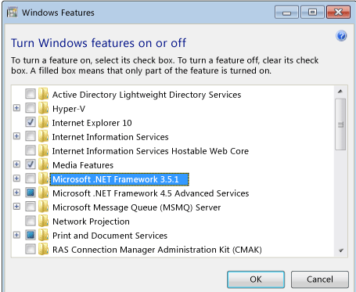

- For Load DynamiX 1G Series Model 3000 or 10G Series Model 5000 project execution on a Linux workstation, see Section H.

Management WorkStation to Appliance Communications

For the Load DynamiX TDE to function properly, the TDE must be able to send and receive HTTP packets with the Appliance. To test communications between WorkStation and Appliance try the following:

- From a browser on the WorkStation, type the Appliance <IP Address> into the address bar and the word SwiftTest should appear in the browser window.
- If #1, does not work: From a command prompt on the WorkStation, Ping the Appliance IP address (Windows command: ping <IP Address>)
- If #2 does not work: From a command prompt on the WorkStation, run a trace route (Windows command: tracert <IP Address>)

If any of the above tests fail, the WorkStation and Appliance will not be able to communicate.

Management WorkStation HTTP Proxy Configuration

If an HTTP proxy has been enabled for the computer running the TDE, be sure to either add the address for the Load DynamiX Appliance to the HTTP proxy or disable the HTTP proxy setting for the computer running the TDE.

Software Installation

- The software is available on a Load DynamiX USB thumb drive or from the Load DynamiX FTP site.
    - If you are downloading the GUI software from the Load DynamiX FTP site, copy the Load DynamiX .zip file to your computer.
      - Load DynamiX FTP site: https://loaddynamix.egnyte.com/
      - Uncompress the .RAR file. If you do not have a program to uncompress the file you can download winRAR from rarlabs.com or other RAR sites.
      - Copy the .msi file to your computer.

  - If you have the Load DynamiX 1G Series Model 3000/10G Series Model 5000 thumb drive, insert the disc into the Load DynamiX WorkStation's USB port.

- Double click the icon SwiftTestTDE.msi. Follow the setup instructions.

E) LICENSING

Load DynamiX licenses Appliances on a per-Protocol basis. This means that, on a per-Appliance basis, each Protocol that is to be used on that Appliance must be enabled in the license that is associated with that Appliance. An Appliance will NOT execute Projects that contain Protocols for which it is NOT licensed. The TDE itself is not licensed but the TDE is the tool that is used to administer licenses for Appliances. Once an Appliance is Licensed, downgrading to a prior release will not undo Activation or any Licenses installed.

Licensing Process Terminology:

Protocols: The basic unit of licensing. Purchase of the Load DynamiX product requires purchasing the use of various protocols - for example CIFS-SMB, NFSv3, iSCSI possibly Client and Server. Appliances will be licensed for all of the Protocols that a user has purchased.

Temporary Licenses: A Temporary License is a license for one or more Protocols that is valid up to a certain Date. It is useful when evaluating a new Protocol before deciding to purchase the license for that Protocol.

Permanent Licenses: Most licenses are Permanent. When a user purchases an SMB2 Client and Server Protocols, they are purchased permanently and will be licensed as such.

Emergency Licenses: If for some reason an Appliance license file does not work, the user can create an Emergency License from the License Management window to enable all Protocols for 7 days. Once the Emergency License expires, it is NOT possible to create a new Emergency License until a Temporary or Permanent License has been installed.

Activation: Preparing an Appliance to be licensed. The Activation process installs an Activation Record on the Appliance and enables the Appliance to accept Protocol licenses. Activation of Appliances installed in customer facilities is only required for Appliances that were shipped before May 2013. The easiest way to check if an Appliance is ready for licensing is to open the Ports & Appliances Window and select the Appliances Tab.

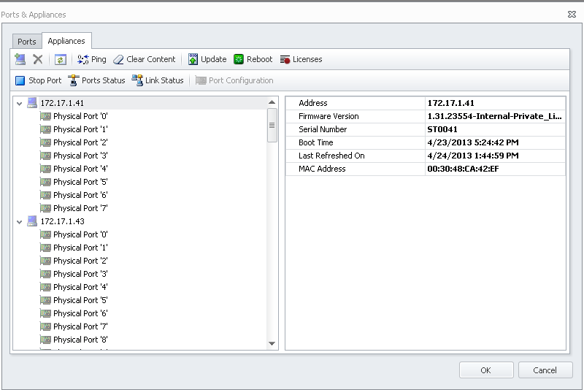
Click the Licenses button and if the following dialog appears, the Appliance is not currently not running the appropriate revision of the Load DynamiX firmware
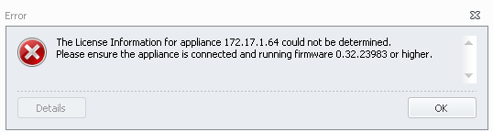
If instead of the error dialog above, the user gets the following message then the Appliance is ready to be Activated. If the Appliance is already Activated, the user will see either the empty License Management window shown below in the Ready For Licenses section or the License Management window with Licensed Protocols shown in the Licensed section below.
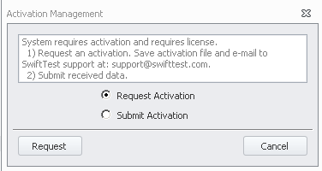
Ready For Licenses: An Appliance is ready for licenses once it has been Activated. Clicking on the License button in the Ports & Appliances > Appliances Tab will open the following License Management window which shows no licenses installed yet. This Appliance will not run any Load DynamiX Projects because none of the Protocols are licensed.
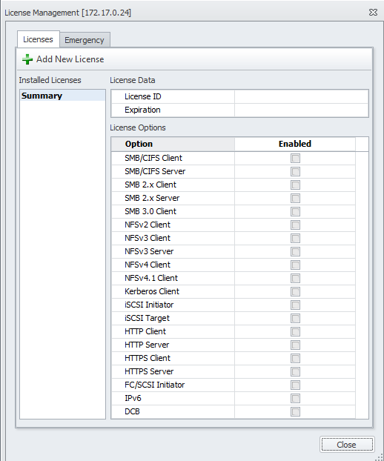

Licensed: When the License Management window shows active licenses then the Appliance is ready to run Projects that contain the licensed Protocols (and ONLY the licensed Protocols). The following License Management window shows active licenses.
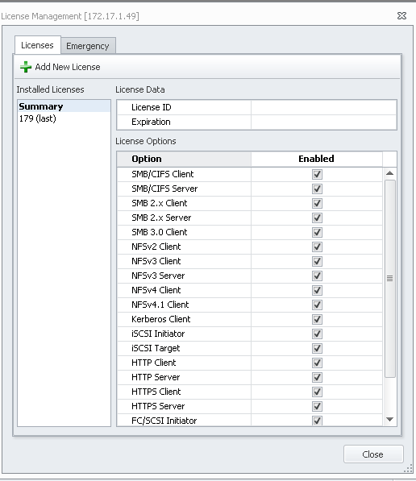

Licensing Process:

This process must be repeated for every Appliance that is to be Licensed.

If an Appliance is Licensed, the set of Protocols which are licensed an Appliance will appear when the Ports & Appliances > Appliances Tab, Licenses button is pressed. Licensed Protocols will be indicated by check marks in the Enabled column as seen here.

If the Appliance is not Activated then open the Ports & Appliances window > Appliances tab. Highlight the Appliance to be Activated and click the Licenses button . When the Activation dialog appears

click the Request Activation radio button and then click . The TDE will open a dialog box which allows the user to save the Activation File on his computer's hard drive. The file will be named <Appliance Mac Address>_request.txt.

This file must be emailed to Load DynamiX Support so that Support can create the Activation Record and License File for this Appliance. Save the file to a folder and then email it as an attachment to Load DynamiX Support. When Load DynamiX Support responds to this email they will provide the user with two files:

Activation Record: <Appliance Mac Address>_<Appliance Serial Number>.activation.txt
License File: <Appliance Serial Number>_license.txt

Save these files to the computer's hard drive.
Click the Licenses button in the Ports & Appliances >Appliance tab with the Appliance to be licensed highlighted and then click the Submit Activation radio button and select the <Appliance Mac Address>_<Appliance Serial Number>.activation.txt file. The TDE will deploy the Activation Record and then immediately open the License Management window.

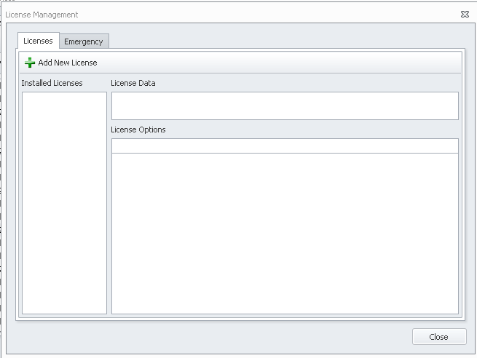

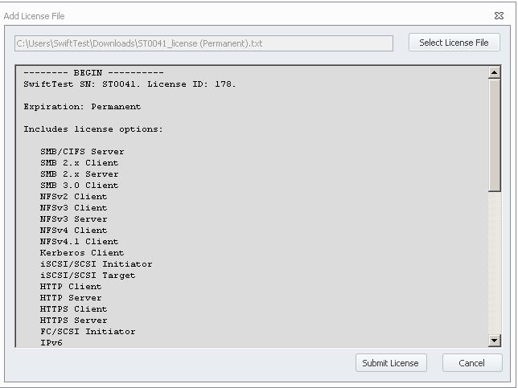
Click the Add New License button and select the License File: <Appliance Serial Number>_license.txt and the contents of the License File will be displayed in the window .
Click  to deploy the License File and the supported Protocols will be displayed on the right side of the window.

The Appliance is now ready to run projects that contain the Protocols that appear on the right side of the window.

Emergency License
If for some reason an Appliance License file does not work, use the Emergency License.

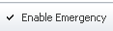
Click the Emergency Tab on the License Management window and then click the Enable Emergency button which will enable all Protocols on this Appliance for 7 days.

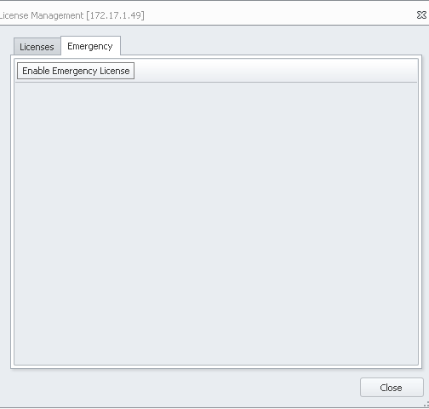

F) Initial System Configuration
- Start the Load DynamiX Test Development Environment (GUI) by double clicking on the icon on your desktop or in the Start menu. Occasionally, on a Windows 7 system, the TDE will not start unless it is Run as Administrator. If after attempting to execute the TDE, an error dialog box saying that the "Load DynamiX TDE has stopped executing" pops up, right click on the TDE icon and select Run as Administrator. This is only required the first time the TDE is executed.

Click Project Library window in the lower left corner of the main GUI window.

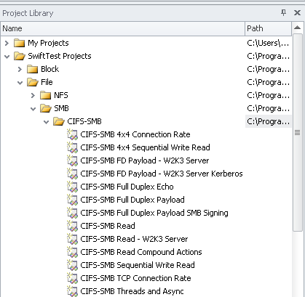
      - Click SwiftTest Projects then open the File then SMB then CIFS-SMB folders.
      - Double click the CIFS-SMB Full Duplex Payload project.
      - The sample test is Read-Only. Save a copy in your My Projects directory.

Establish a connection from the TDE to the Appliance:

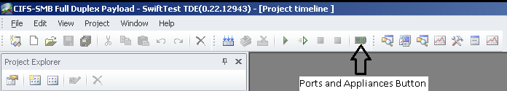
  - Click the Ports & Appliances icon in the TDE Toolbar.

  - Select the Appliances tab in the Ports & Appliances window.

  - Click the Add Appliance icon at the top left of the window.

  - Type the Management IP address of the Appliance and click Add.

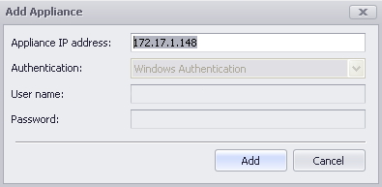
Ensure the Appliance is running the latest software:

  - Click the IP address of the Appliance and click the Update Appliance Firmware icon .
  - The Firmware File input field will be loaded with the path to the Load DynamiX Appliance firmware (swift-*.tgz) that is delivered with this TDE.
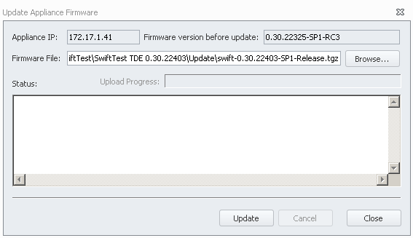

  - Click the Update button to download the firmware to the Appliance. Browsing for the swift.tgz file is only required if a different firmware version is to be uploaded to the Appliance.

  - When the update finishes click Close.

  - Click the Reboot icon. (Steps e. , f. and g. are not required but recommended)

  - Click Reboot in the Reboot Appliance window.

  - When the reboot finishes, click Close.

- Return to the Ports tab and connect the Appliance Client Port 0 and Server Port 4 to the physical ports on the Appliance that are connected to each other (back-to-back). Assume that on the Appliance physical port 0 is connected to physical port 4:

  - Click Ports on the Ports & Appliances window.

  - Drag Physical Port '0' to Client Port 0.

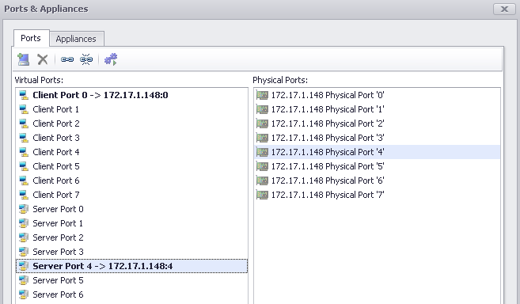
  - Drag Physical Port '4' to Server Port 4 (or if using a Load DynamiX 10G Series Model 5000 Appliance, drag Physical Port '1' to Server Port 4).

  - Click OK.

Run the Sample Test

- After following the steps described above in Initial System Configuration, click the Start Button icon in the TDE Toolbar or press F5 to begin the test.

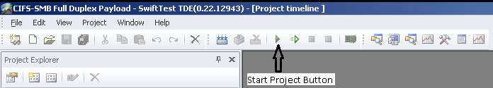

- View statistics during and after the test:
  - Click View->Results Explorer to view test statistics.

  - Expand the Results folder with the current date and time.
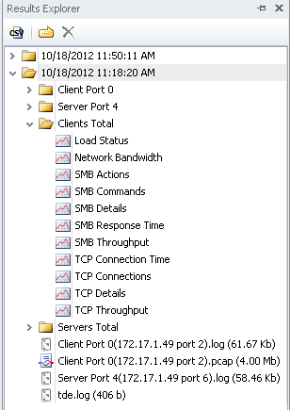

  - Expand Clients Total folder.

  - Double click the SMB Throughput report to view CIFS-SMB throughput.

      - If no results display, it’s likely that the wrong ports have been selected for the test or that the Ethernet cable used for the back-to-back connection is bad. Check the Ports and Appliances Window to ensure that physical ports that have been connected back-to-back have been selected. If port settings are correct, replace the Ethernet cable.
      - If you see results for SMB (e.g. you see SMB Actions, SMB Throughput, etc graphs), continue to the next step. If not, check to ensure the cable is connected between physical Ports 0 and 4 (the two top-most Test Ports). If this does not solve the problem, contact Load DynamiX support (support@loaddynamix.com).

  - Double click the Network Bandwidth report to view total Ethernet bandwidth or TCP Throughput. Click the blue A at the top of the window to view the total throughput for each polling interval. You should see 1.9 Gbps (or higher) throughput if you are running this test on a Load DynamiX 1G Series Model 3000 Appliance (or 15Gpbs or higher on a Load DynamiX 10G Series Model 5000).
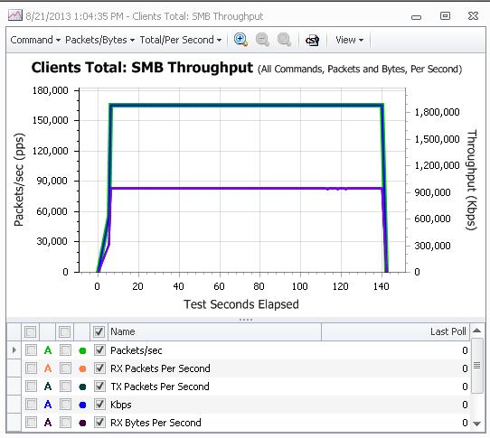

  - If the back-to-back test is successful, the Load DynamiX Test Development Environment and the Load DynamiX Appliance are operating correctly. If you see low/zero bandwidth or errors, there is likely a problem with the Ethernet cable.

- Once the back-to-back test is successful, connect an Ethernet cable from Test Ports 0 and 4 (or ports 0 and 1 on a 10G Series Model 5000 Appliance) into a 1 (or 10 if using a 10G Series Model 5000 Appliance) Gbps-capable Ethernet switch.

  - Re-run CIFS-SMB Full Duplex Payload test to verify sending data through your network. Now that the Physical Ports are now connected through your switch/network, the same test should still work, but you will likely experience lower throughput, depending on the capability of your switch/network. As in Step 2 f. above, if you see low/zero bandwidth or errors, you either have a problem with the Ethernet cables or the Ethernet Switch, and you should seek help from a network engineer.

- Click the Start icon again and view the results by expanding the results folder with the most recent date & time. If you see comparable throughput, then you know that the test is working correctly. On a Load DynamiX 1G Series Model 3000, verify the remaining port pairs (1 & 5, 2 & 6, 3 & 7) by using the Ports & Appliance window to assign these physical ports to the Virtual Ports using this test.

G) Running Load DynamiX Projects

The GUI Software Installation, Initial System Configuration and Run Sample Test steps above ensure that your Load DynamiX TDE is installed correctly, can communicate with your Load DynamiX Appliance and that the Appliance is functioning correctly in a back-to-back scenario. To ensure that you are able to move forward with more relevant testing, consider these suggestions.
- Ensure that enough Client IP addresses, user names and passwords have been configured in the test environment.
- If domain-based authentication is required, ensure a Domain Controller with sufficient processing capability is in the test bed and accessible to test ports, and that the Domain Controller is properly configured. Ensure that all required configuration parameters are available.
- If Shares are required: Ensure that any server to be tested has been provisioned with the required number of shared folders for testing and ensure that every share has all permissions set for the folder, sub-folders and files.
- Avoid testing through switch ports with the Spanning Tree Protocol enabled if possible. If Spanning Tree is required, notify Load DynamiX support for Project setup guidance.
- For performance testing, limit the network infrastructure associated with a test. A direct-connected cable from an appliance test port to a device is best. If this is not possible, limit the test bed to one Ethernet switch with no other shared traffic. If this is not possible, performance will likely be limited by the test bed, not the Load DynamiX appliance or device under test.
- For functional testing, be careful not to oversubscribe any links between the Appliance and the device under test. Random errors may be introduced into tests if this best practice is not followed.
- Use one of the Sample projects that is relevant to your test needs. For example, if you are testing an SMB2 compatible device, use one of the Load DynamiX SMB2 sample Projects as a template. Configure it as appropriate to your environment and click the Validate Test button. If the test fails, notify Load DynamiX support. (Note – the test should include all required elements to ensure the test bed is correctly configured).
- Use of an incompatible SFP+ transceivers on a Load DynamiX 10G Series Model 5000 Appliance will cause an error message containing the text “<ERROR: Device[0] Generic Failure: Status Code [13]>” to be received from the Appliance and displayed in the Output Window and in the Client or Server log file.

H) Information Typically Required to Design a Load DynamiX Project

Some pieces of information that will be helpful to know before beginning to design a Project using the Load DynamiX TDE

Device Under Test IP Address(es): Load DynamiX Projects require a device under test to connect to and that device is specified by its IP Address. Is just a single IP address required (for example, NFSv3 tests require three separate connections, are these connections to the same IP Address)?
Protocol: Which Protocol (CIFS-SMB, SMB2, NFSv2, NFSv3, NFSv4, NFSv4.1, Fibre Channel, iSCSI, HTTP) is to be tested?
TCP Ports: Which TCP Ports will be used (CIFS-SMB:445, SMB2:445, NFSv2:2049, NFSv3:111/627/2049, NFSv4/4.1:2049, iSCSI:3260, HTTP:80 or others)?
Domain/Machine Name: CIFS-SMB and SMB2 allow input of Domain and Machine Name in their authentication commands. What values are to be used, if any?
Authentication Method: All Load DynamiX supported protocols require some form of authentication . Be sure to know what authentication method the device under test uses to authenticate access.
Users: How many and what are the User names and passwords that will be used during the test.
Filesystems and Files: Most Load DynamiX protocols are are file-oriented (CIFS-SMB, SMB2, NFSv2, NFSv3, NFSv4, HTTP). What filesystem (volume or share name) and files are going to be used? Are the files going to be created or must they exist in advance? What type of files are required (regular, device, link, pipe, stream, etc)?
URI: The HTTP protocol requires URI information to access files.
IQN: The iSCSI Protocol requires ISCSI Qualified Names for Clients to log in to iSCSI Servers.
LUN: The iSCSI Protocol requires specific Logical Unit Numbers for data read and/or write operations.
Size: How many megabytes, terabytes, gigabytes are going to be required for the test. Does the filesystem or LUN have the capacity that is required?
Load: How much load does the test need to place on the device under test?
Duration: How long should the test run?
Throughput: What throughput (packets/sec, kilobytes/sec, etc) is required or desired?

Information Required Decision Matrix

Protocol | IP Addr | Ports | Dom/Mach Name | Auth | User Names | File-systems | Files | URI | IQN | LUN | Size | Load | Duration | Throughput
CIFS-SMB | YES | YES | YES | YES | YES | YES | YES | NO | NO | NO | YES | YES | YES | YES
SMB2 | YES | YES | YES | YES | YES | YES | YES | NO | NO | NO | YES | YES | YES | YES
NFSv2 | YES | YES | NO | YES | YES | YES | YES | NO | NO | NO | YES | YES | YES | YES
NFSv3 | YES | YES | NO | YES | YES | YES | YES | NO | NO | NO | YES | YES | YES | YES
NFSv4 | YES | YES | NO | YES | YES | YES | YES | NO | NO | NO | YES | YES | YES | YES
iSCSI | YES | YES | NO | YES | NO | NO | NO | NO | YES | YES | YES | YES | YES | YES
HTTP | YES | YES | NO | YES | YES | YES | YES | YES | NO | NO | YES | YES | YES | YES

I) Load DynamiX Automation on Linux
For more details on Automation, please see the discussion in the TDE online help:
Appendix: Test Automation.

J) Appliance Admin User Interface

When telneting into a Load DynamiX Appliance, the user is presented with a typical Login prompt for User ID and Password. The only available User ID and Password for the Load DynamiX Appliance are:

User ID == Config
Password == Config

The user interface that appears when logging in as Config/Config is:

Main Screen
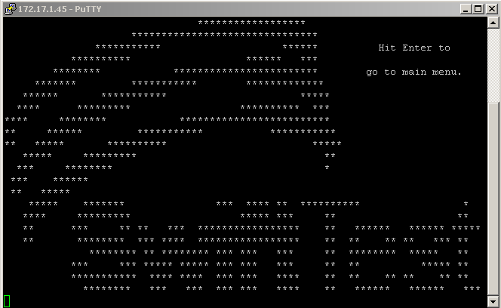

TO SET APPLIANCE IP ADDRESS

Press the Enter key
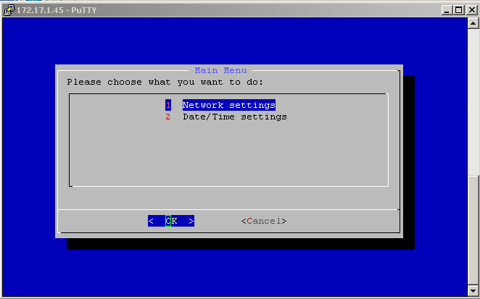

Select 1 Network Settings or 2 Date/Time settings to pick the operation desired and then hit Enter. Select 1 Network Settings

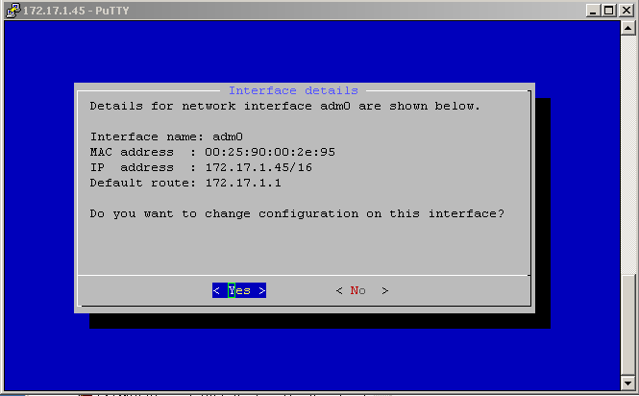

Click Yes
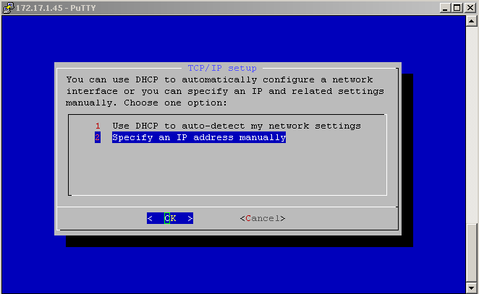
Enter 2 and hit the Enter key to get the IP Address Manual setting page
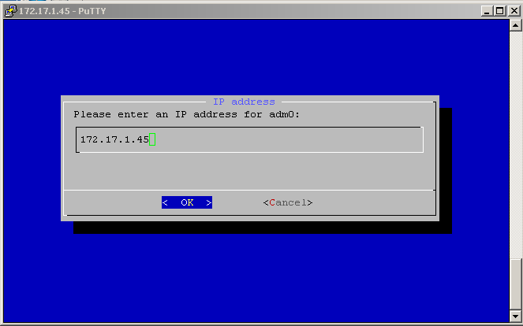

Enter the desired IP address for the Appliance and then hit the Enter key. Tab over to <Cancel> to abort this operation.

TO SET APPLIANCE TIME AND DATE

To set the Date and Time, enter 2 Date/Time settings and hit the Enter key from that main menu selections page
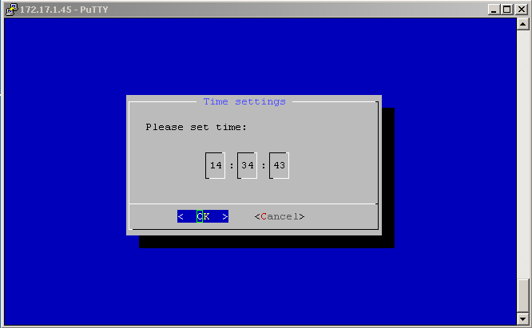
Enter the time of the Pacific Time zone in 24 hour mode and then hit the Enter key with <OK> selected.
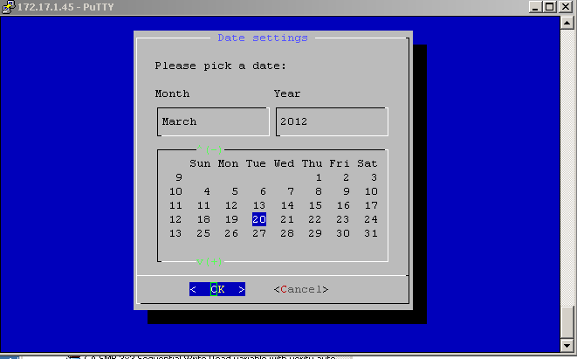
Click on the Month and Year columns and use the Up and Down Arrows to change month or year and click on the appropriate day of the month and hit the Enter key.

K) Troubleshooting Tips

Installation
The Load DynamiX TDE is dependent on the .NET framework version 3.5.1. Please be sure that version 3.5.1 is present on the Load DynamiX Workstation.

The HTTP protocol is used to communicate between the Load DynamiX Workstation and Appliance. The Load DynamiX Workstation must be able to send HTTP packets to the Load DynamiX Appliance.

Project Execution
Appliance Error messages

<ERROR: Device[0] Generic Failure: Status Code [13]> results from the use of an incompatible SFP+ transceivers on a Load DynamiX 10G Series Model 5000 Appliance.

Product Features
There are a number of capabilities that the Load DynamiX product provides that are intended to help determine if the desired results are achieved.

PCAP (Tracing Parameters) - packet capture and review is often one of the easiest ways to find issues with test programs including items such as:
Source and Destination IP addresses
Protocol specific data (e.g. SMB or NFS file names, directory names, read and write buffers, return codes)
Event order (in what sequence to different Actions take place)

NOTE: Tracing Parameters are not a performance tool. Using Tracing Parameters to capture PCAP data will reduce performance in the Load DynamiX Client and Server software.

Results Folder - the results folder contains the statistics and log files that are captured during the execution of a Load DynamiX test
Statistics - statistics are captured real time and may be observed by opening the Results Folder during a test run and selecting the statistic that is interesting.
For example,
SMB Commands – view counts of the number of commands of a given type executed
Load Status - to see how the various Scenarios launched by the test are doing, etc.

While these statistics can be used for real time evaluation of the progress of a test, they are also excellent troubleshooting tools.

Client and Server Port log files - at the end of a test run, the Load DynamiX appliance sends a log file to the TDE containing execution details for the test. There is a log file for each virtual port in the test and this log file can be immensely helpful in determining the cause of test failures. Network statistics are captured in Client and Server log files for debugging purposes. These statistics can be used to debug issues at the lowest levels of the communications process. The following measurements with non-zero values may indicate that the Load DynamiX hardware and software are having difficulties sending and/or receiving packets.

rx packets dropped - indicates that the Load DynamiX Appliance received packets that it then was unable to process due to the packet's contents or status

tx packets dropped - indicates that the Load DynamiX Appliance software attempted to send more packets than the Device Under Test could handle

rx packets out of buffer space - indicates that the Load DynamiX Appliance software is unable to receive packets at the rate that they are being received by the hardware.

missed packet errors count - indicates that the Load DynamiX Appliance hardware is unable to receive packets from the wire at the same speed in which they are arriving

These statistics are reported as Rx and Tx Errors in the Network Bandwidth graph..

